Description:

This project is to implement merchant-side floor plan functionality with React framework.

Basic Requirements:

* Use GitHub to source control the project development
* Code can be executed and runnable in the localhost

Optional:

* UI improvement is a plus
* User experience improvement is a plus

Merchant portal -- Tables -- Dine In  
For the left part, no need to create other tabs apart from Tables

Same to Dine In (No need to create Pick Up tab)

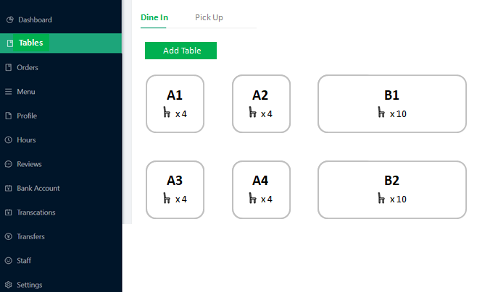

Click on [Add table]

length and width: 1, 2, 3, 4

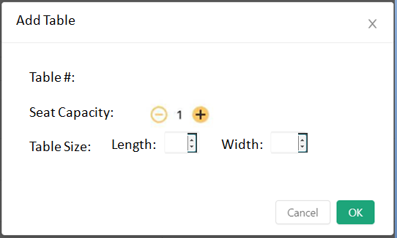

Click on existing table

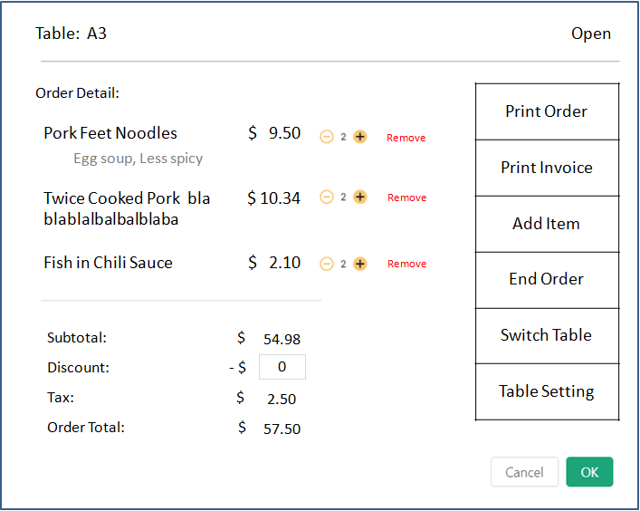

Click on Table Setting

